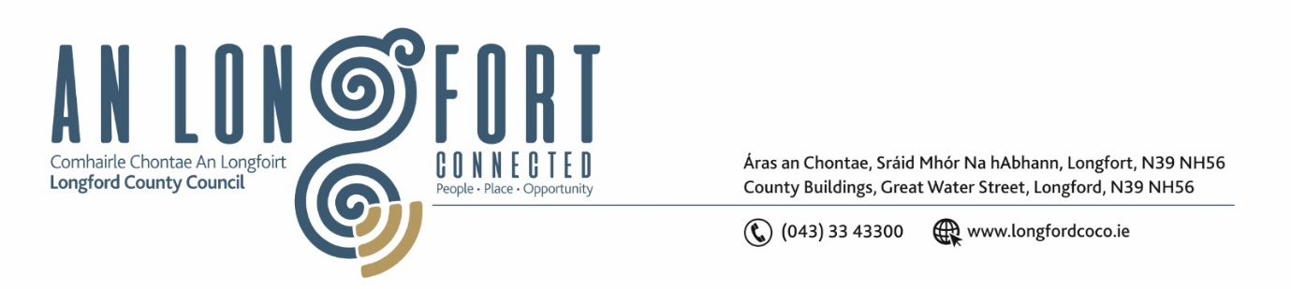**LONGFORD MUNICIPAL DISTRICT**

**Minutes of Meeting of Longford Municipal District held in the Council Chamber Aras an Chontae and via MS Teams on Wednesday, 28 June 2023 at 3.30pm**

**CATHAOIRLEACH**: Councillor Martin Monaghan

**MEMBERS PRESENT**: Councillors – Gerry Hagan, Uruemu Adejinmi, John Browne, Seamus Butler, Peggy Nolan

**IN ATTENDANCE**: Mr. John Brannigan, Director of Services

Mr. Michael Nevin, A/Director of Services

Mr. Eamonn Bennett, Senior Executive Engineer

Ms. Lorraine McKee, Administrative Officer

**MEETINGS**

**ADMINISTRATOR:**  Ms. Claire McNabola

**APOLOGIES:**  Councillor Gerry Warnock

1. **ADOPTION OF MINUTES – circulated**
2. On the proposal of Councillor John Browne seconded by Councillor Peggy Nolan it was unanimously agreed to adopt Minutes of Meeting of Longford Municipal District held on the 24 May 2023.
3. On the proposal of Councillor Seamus Butler seconded by Councillor Peggy Nolan it was unanimously agreed to adopt Minutes of Committee Meeting of Longford Municipal District held on the 24 May 2023.
4. **MATTERS ARISING FROM MINUTES**

Councillor Seamus Butler requested an update on the revenue from parking fees in the town. Director of Service John Brannigan confirmed these reports are being prepared and will be available at the next meeting.

Councillor Gerry Hagan asked for an update on the transition of the Longford town parking meters to smart/card machines. Senior Executive Engineer Eamonn Bennett advised that this contract has gone to tender and will be implemented in a phased manner.

1. **DECLARATION OF INTEREST BY MEMBERS**

None.

1. **MANAGEMENT REPORT - circulated**

The Management Report, as circulated, was noted.

Senior Executive Engineer, Eamonn Bennett highlighted the works in the area since the last meeting and noted the upcoming works.

Councillor John Browne highlighted the issue of speeding on the Ardagh Road. Eamonn Bennett advised the members that the Roads section could place temporary flashing lights along this stretch of road as it is an approved location. Director of Service John Brannigan agreed to write to the Gardaí on this issue.

Councillor Seamus Butler asked about extending the footpath at Aghafad out to Ballymacormick Cemetery. Eamonn pointed out that the National Transport Authority will not install a footpath along a road where the speed limit is 80km/hr.

Councillor Butler suggested reducing the speed limit on this stretch of road to accommodate this project. Eamonn confirmed that this could be considered under the next speed limit review.

Councillor Peggy Nolan highlighted the poor state of the roadway at Abbeycartron Lane. Eamonn agreed that these works will be arranged if necessary.

1. **CONSIDERATION OF FUNDING FOR LONGFORD SUMMER FESTIVAL 2023**

On the proposal of Councillor Gerry Hagan, seconded by Councillor Uruemu Adejinmi it was unanimously agreed to fund in principle the Longford Summer Festival up to €12,000.

Councillor Gerry Hagan highlighted the importance of the Longford County Council branding being promoted on all Longford Summer Festival promotional materials.

Councillor Seamus Butler proposed that it be incumbent on the organisers to cease public money collection. This was seconded by Councillor Gerry Hagan.

1. **CONSIDERATION OF PART VIII NO. 107 –** **PROPOSED EXTENSION AT 5 THE HOLLOWS, GLACK, CO LONGFORD - REPORT IN ACCORDANCE WITH SECTION 179 OF THE PLANNING AND DEVELOPMENT ACT 2000 (AS AMENDED) AND PART 8 OF THE PLANNING & DEVELOPMENT REGULATIONS 2001 (AS AMENDED) – AS CIRCULATED**

On the proposal of Councillor Seamus Butler, seconded by Councillor Uruemu Adejinmi, the members unanimously agreed to adopt the Part VIII Number 107 - Proposed extension at 5 The Hollows, Glack, Co Longford, as per report circulated.

1. **NOTICES OF MOTIONS, SUBMITTED BY COUNCILLORS, AS LISTED HEREUNDER:**

**The following notice of motion was proposed by Councillor Gerry Warnock, brought forward by Councillor Peggy Nolan and seconded by Councillor John Browne**

I'm calling on Longford MD to install a Convex Safety Mirror at the junction at Annaly Park and Richmond Street (N5). Clear line of sight cannot be achieved on the righthand side when exiting Annaly Park due to a boundary wall, and this represents a potential road safety issue.

**Response**

A convex mirror is not an approved sign in the Department of Transport “Traffic Signs Manual”. These signs are typically erected opposite private entrances by individuals. They are not erected by Local Authorities.

The boundary wall issue at this junction was subject of discussion between Longford Co Co and the landowner in 2016/17. A planning application by the landowner was subsequently lodged and permission was granted by Longford County Council for the removal and setting back of the boundary wall. The carrying out of this work currently sits with the landowner.

Director of Service John Brannigan agreed to write to the landowner on this issue.

**The following notice of motion was proposed by Councillor Peggy Nolan and seconded by Councillor Martin Monaghan**

I wish to ask this Council to put line markings and signage in place with immediate effect at Legion Terrace, Longford.

This onetime cul-de-sac is now facilitating two housing developments with construction ongoing to deliver much needed housing. The current volume of traffic in this area needs assessing, and funding made available to address the dangerous situation that is causing great concern to the resident’s health and safety. At this stage, it needs to be addressed.

**Response**

Roads staff will reinstall the road markings and install stop signs as needed at Legion Terrace.

The ongoing construction project is a Longford County Council housing section project. The issue of the management of construction traffic and its impacts on the use of Legion Terrace will be addressed by the housing section.

Councillor Nolan thanked Eamonn for the swift action taken in this area.

This concluded the business of the meeting.

**Signed: ____________________**

**Claire McNabola,**

**Meetings Administrator.**

**Confirmed and adopted at Longford Municipal District Meeting held on the 28 June 2023.**

**Signed: _______________**

**Cathaoirleach.**